Project Documentation: Full Stack Development with MERN

1. Introduction

Project Title:
Book-Store Web Application

Team Members:
- Member 1: [Full Stack Developer] – Fanish Kumar Diwan

2. Project Overview

Purpose:
The purpose of this project is to create a fully functional Book Store Web Application using the MERN stack. The application will allow users to browse, purchase, and manage books. The goal is to provide an easy-to-use interface for customers, a secure and efficient system for managing inventory, and a user-friendly admin dashboard for managing users and books.

Features:
- User Registration & Login: Allow users to register and log in to access the store.
- Book Management: Users can browse, search, and filter books by category, price, and author.
- Shopping Cart: Users can add books to the cart and proceed to checkout.
- Order Management: View past orders and track deliveries.
- Admin Panel: Admin can manage books, orders, and user information.
- Authentication: Secure login with JWT tokens for session management.

3. Architecture

Frontend:
The frontend is built using React.js, a JavaScript library for building user interfaces. It is component-based, allowing for a modular, reusable code structure. We use React Router for navigation and Redux for state management.

Backend:
The backend is powered by Node.js and Express.js, providing a RESTful API for interacting with the database and managing user requests. JWT (JSON Web Tokens) are used for secure user authentication.

Database:
The application uses MongoDB, a NoSQL database, to store book data, user information, and order details. The database schema includes collections for users, books, orders, and cart items.

4. Setup Instructions

Prerequisites:
- Node.js (v14 or higher)
- MongoDB (local or Atlas)
- npm (Node Package Manager)

Installation:
- Clone the repository from GitHub:
git clone https://github.com/fanishkdiwan/Book-store-MERN.git
- Navigate to the project directory:
cd build-full-stack-book-store-mern-app
- Install dependencies for both the client and the server:
  - For Client (React frontend):
npm install
  - For Server (Node.js backend):
npm install
- Set up environment variables:
  - In the client and server directories, create .env files and configure the necessary variables such as the MongoDB URI, JWT secret, etc.

5. Folder Structure

Client:
- /src: Contains all React components and pages.
- /components: Reusable components like buttons, forms, etc.
- /pages: Pages such as Home, BookDetail, Cart, Checkout, etc.
- /redux: Redux store and reducers for state management.

Server:
- /models: Contains MongoDB models for books, users, and orders.
- /routes: API routes for handling requests.
- /controllers: Business logic for processing data from requests.
- /middleware: Authentication and authorization middleware.

6. Running the Application
To run the application locally:
- Start the frontend (client):
npm start
- Start the backend (server):
npm start
This will run the frontend on http://localhost:3000 and the backend on http://localhost:5000 by default.

7. API Documentation

1. Register User
- Endpoint: POST /api/users/register
- Parameters: name, email, password
- Response: Success message and token.

2. Login User
- Endpoint: POST /api/users/login
- Parameters: email, password
- Response: JWT token on successful login.

3. Get All Books
- Endpoint: GET /api/books
- Response: List of all books.

4. Add Book (Admin)
- Endpoint: POST /api/books
- Parameters: title, author, price, category, image_url
- Response: Success message.

8. Authentication
Authentication is handled using . On successful login, a token is generated and sent to the user. This token must be included in the headers of subsequent requests for authenticated routes.

9. User Interface

Screenshots:
Include the following screenshots or GIFs of key UI features:
- Home Page showing the list of books.
- Book Detail Page with more information about a book.
- Cart Page where users can review their cart.
- Admin Dashboard for managing books and users.

10. Testing
The application was tested using Jest for unit testing of React components and Mocha/Chai for testing the backend API.

11. Screenshots or Demo
- Screenshots of key pages (Home, Book Details, Cart, Admin Dashboard, etc.) can be added.
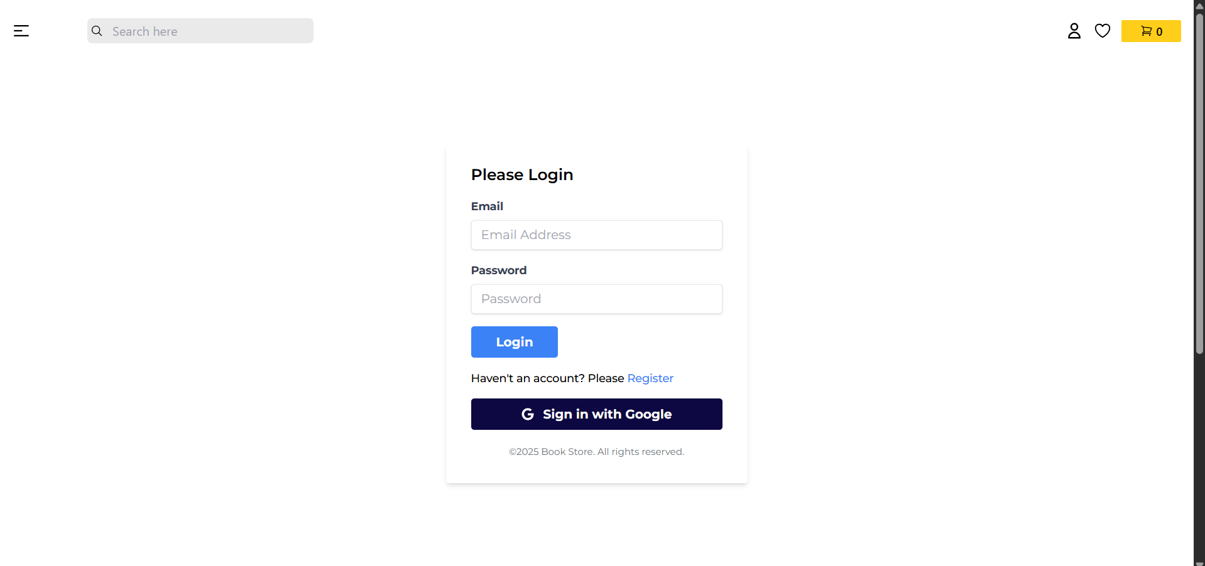
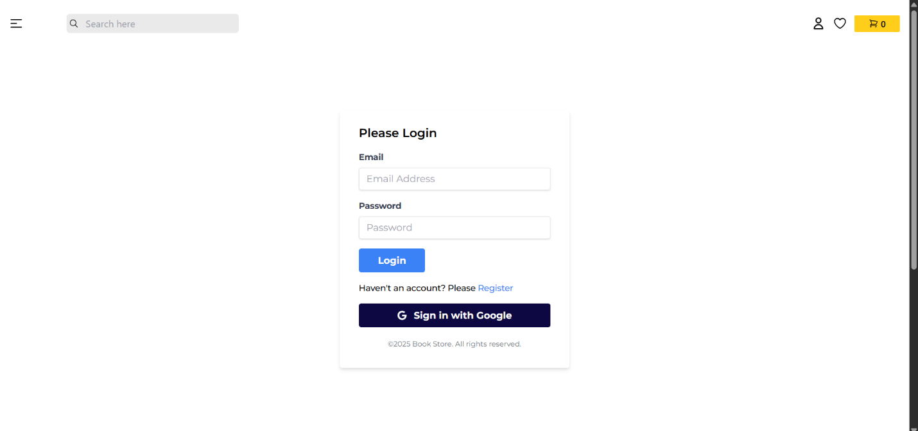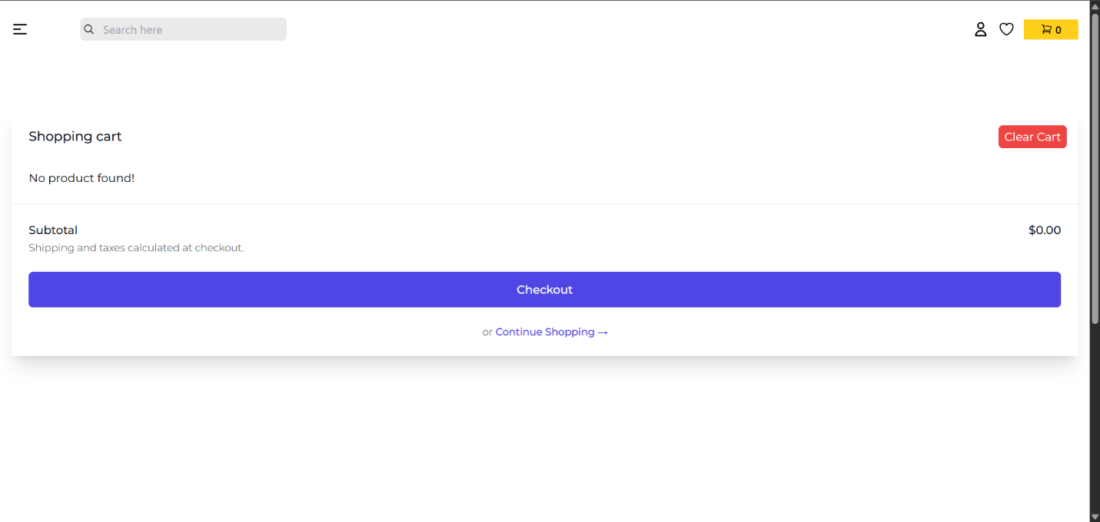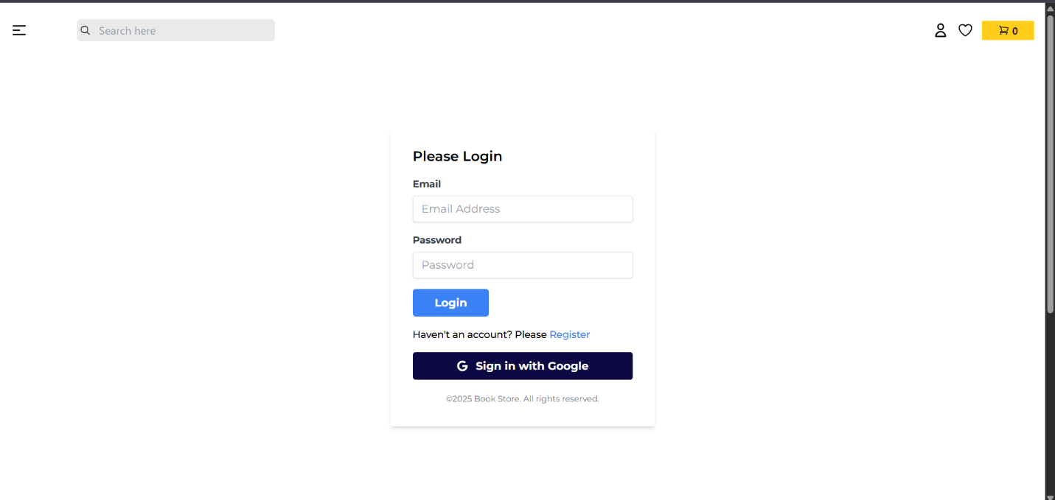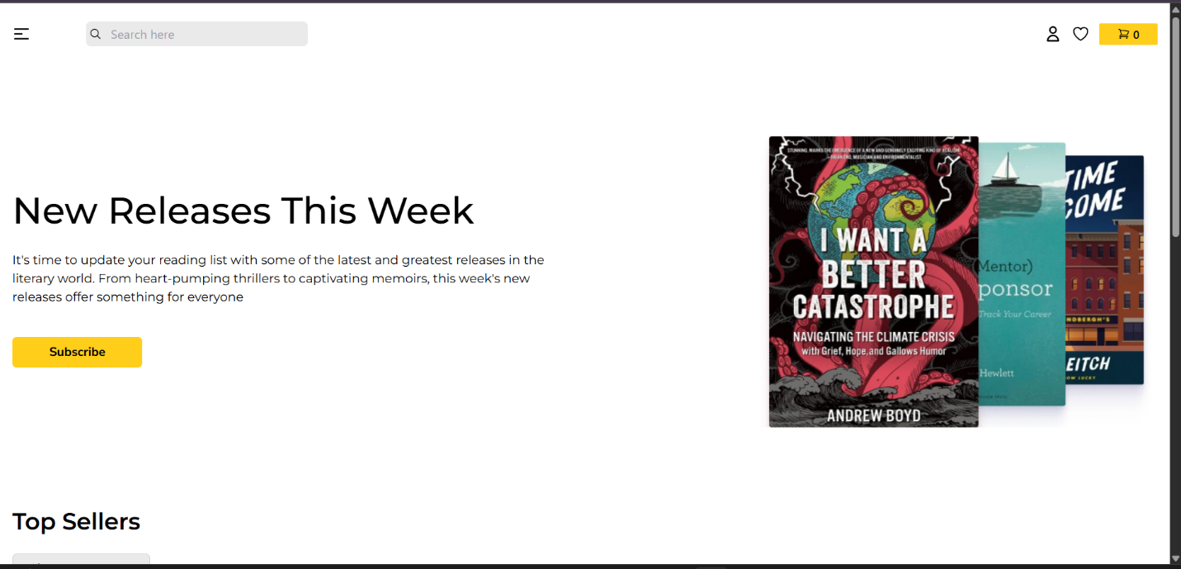

12. Known Issues
- There may be occasional delays in order processing, which is under investigation.
- Currently, user password reset is not implemented.

13. Future Enhancements
- Product Search: Implement a search bar to allow users to search for books by title, author, or category.
- Payment Gateway Integration: Integrate PayPal or Stripe for real-time payments.
- Rating System: Allow users to rate and review books.
- Admin Roles: Add more granular roles for admin users to manage orders and users.

